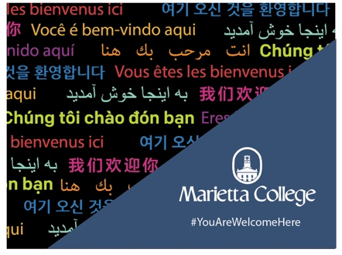
Overview
The #YouAreWelcomeHere scholarship recognizes international students who have a vision for enhancing intercultural understanding. Beginning in Fall 2020, Marietta College will offer 2 annual and renewable scholarships covering 50% tuition. The scholarship is open to new first year, degree seeking international students in any academic major offered at Marietta College. Successful applicants will be dedicated to furthering the #YouAreWelcomeHere message by bridging intercultural divides, engaging on campus and in the Marietta community.

Eligibility Criteria
Be a first-year international applicant to a participating college or university of the #YouAreWelcomeHere scholarship. An international applicant is defined as an individual who holds citizenship in a country outside the US and who does not possess US citizenship or US permanent residency.
Demonstrate interest and personal initiative in activities that encourage intercultural engagement, learning and understanding on the Marietta College campus.

Application Process
- Have a completed application for admission at Marietta College by February 1, 2020

- Submit the #YouAreWelcomeHere scholarship application (including an essay or 2-5 minute video about your ideas for supporting and promoting intercultural learning and understanding on Marietta College's campus) by February 1, 2020 to scholarshipapp@marietta.edu

- Deadline for this scholarship is February 1, 2020. For questions about the application or scholarship, please contact finaid@marietta.edu.

#YouAreWelcomeHere Application Form (Please print or type) 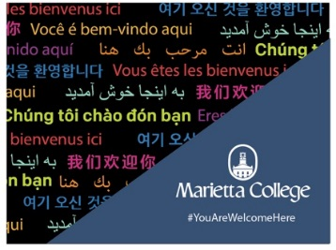

Marietta College welcomes diverse perspectives and promotes an inclusive environment on campus. Applicants for this scholarship understand that they will be expected to participate in various activities on campus that promote intercultural understanding. Please note that a complete application includes this application and essay or this application and a 2-5 minute video. Materials need be submitted along with this form to scholarshipapp@marietta.edu by February 1, 2020.

Legal Name: __________________________________________________________________________
Last name First name Middle

Mailing address:

______________________________________________________________________________
House number and street Apartment number

______________________________________________________________________________
City Province Country Postal Code

Email: _________________________________________ Telephone: ____________________

Country of Citizenship: ___________________________ Date of Birth: __________________
Month/ Day/ Year

Country of Residency: ____________________________

Academic Major(s): ______________________________________________________________

____ I will submit an essay _____ I will submit a video

Applicant Name: ________________________________

Please respond either below in a one-page essay or 2-5 minute video regarding the following prompt: One of Marietta College’s core values is Global Perspective and Diversity. Please describe your vision and ideas for supporting and promoting intercultural learning and understanding on Marietta College’s campus while you are a student.

___________________________________________________________________________________________________________________________________________________________________________________________________________________________________________________________________________________________________________________________________________________________________________________________________________________________________________________________________________________________________________________________________________________________________________________________________________________________________________________________________________________________________________________________________________________________________________________________________________________________________________________________________________________________________________________________________________________________________________________________________________________________________________________________________________________________________________________________________________________________________________________________________________________________________________________________________________________________________________________________
□ I agree that my name, country of origin, academic major, photo and essay/video may be shared publicly in promotion of the #YouAreWelcomeHere scholarship if I am selected for an award.
□ I agree that the information I submitted in this application is truthful and accurate.
X ______________________________________________________________________________
Applicant signature Date

